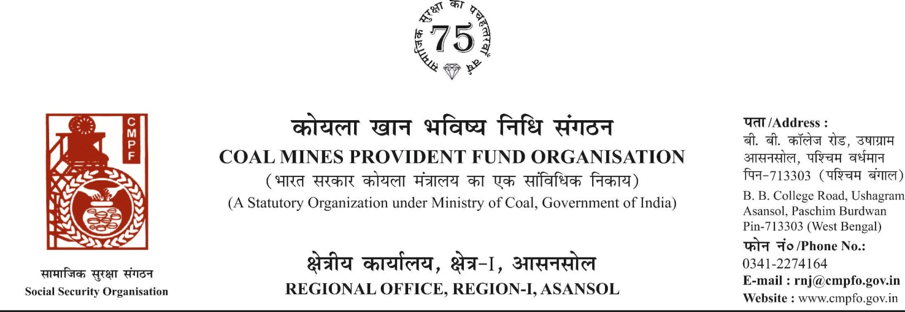

CPF/118/MISC/L.C. IN-OUT/REQ/Voll-2/R-I/ASN Date-12/08/2025
To,
The Regional Commissioner
C.M.P.F , Singrauli
PO-Jayant Dist-Singrauli-486890
Madhya Pradesh

Sub- Sub- Inter-Regional Transfer of Ledger Card
Ref. : ECL/GM/JNR/PER/2025-26/681 Dated. : 05/08/2025
Sir,
In view of the revised procedure prescribed in procedure office order No-230 Dated-12/02/1973 of CMPF Commissioner, Dhanbad, I am to state that the ledger card of the following member is forwarded to your office as he is working under jurisdiction of your region.
It is ensured that the posting in the ledger card are dully completed for the periods for which the member was contributing in this region.
SL. No | Name of the member | CMPF A/C No | Name of the colly where member worked in this region | Name o the colliery where member working in your region
1 | LATE DEB KUMAR ROY | SING/16/1473 | JHANJRA AREA OFFICE  (RNJ/40) | 1-NIGAHI AREA  OFFICE (NCL)08-02-2023 TO MARCH 2008  2-CENTRAL WORKSHOP,JAYANT (NCL)APRIL 2008 TO MARCH 2019

Encl- As above
Yours faithfully

Assistant Commissioner

